**Assignment: 6**

**Experiments**

1. **Write a program to count the number of English alphabets (lowercase and uppercase) in a text file.**

**Coding:**

s = input("Enter the String:")  
f = open("alphabets.txt","w")  
D = f.write(s)  
L = s.lower()  
U = s.upper()  
print("lower case Changed input:",L)  
print("Upper case Changed input:",U)  
print("you have successfully inserted data into the File...")  
count=0  
for i in s:  
 count=count+1  
print("Total alphabets in String:",count)

**Output:**

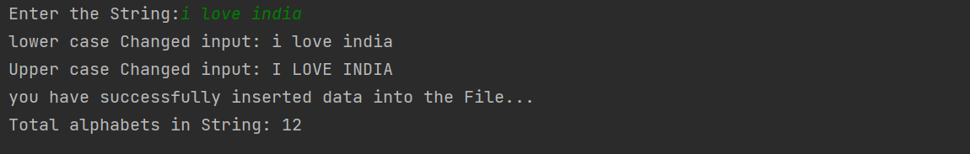

1. **Write a program to count the number of lines in a text file.**

**Coding:**

f=open("my.txt","r+")  
l=f.readlines()  
count=0  
for i in l:  
 print(i)  
 count=count+1  
print("Total lines of this program",count)  
f.close()

**Output:**

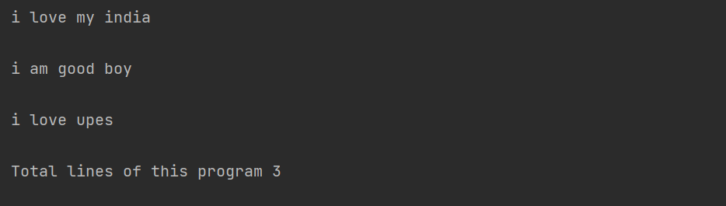

1. **Write a program to count the occurrences of a specific word in a text file.**

**Coding:**

f=open("my.txt","r+")  
l=f.readlines()  
count=0  
for i in l:  
 for word in i:  
 print(word,end=" ")  
 count=count+1  
 print()  
print("All word in a file:",count)  
f.close()

**Output:**

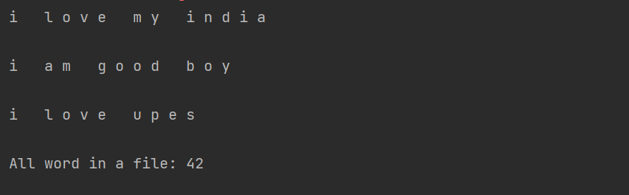

1. **Write a Python program to take input from the user and record it in a file. Once the input is over, program also shows the content of a file.**

**Coding:**

data=input("The record in a string:")  
f=open("my.txt",'w')  
f.write(data)  
print(data)

**Output:**

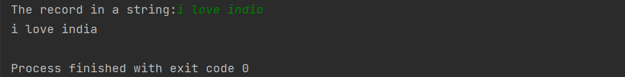

1. **Create a small database of employees that contains following attributes: Name, age, salary**

**Write a menu-driven program to**

1. **(a) List all the employees**
2. **(b) appending a new employee**
3. **(c) Searching for a specific employee**

**Coding:**

import csv  
with open("back.csv",'w',newline='') as f:  
 w=csv.writer(f)  
 w.writerow(["EmployeeName","EmployeeAge","EmployeeSalary"])  
 num=int(input("Enter the number of Employee details"))  
 for i in range(num):  
 EmployeeName=input("Name of Employee:")  
 EmployeeAge=int(input("Employee Age:"))  
 EmployeeSalary=int(input("Salary of Employee:"))  
 w.writerow([EmployeeName , EmployeeAge , EmployeeSalary])  
 print("All Employee inserted successfully...")

1. **Output:**
2. 